Midterm Lab Task 1.
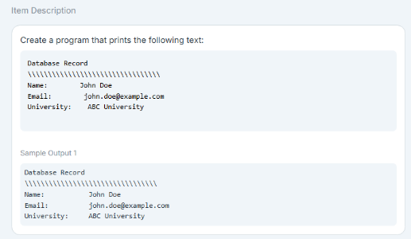
Problem 1. Use Appropriate Escape Sequence ( \n, \t \b \ ..etc) for the problem below

Code:
  - print("Database Record\n\\\\\\\\\\\\\\\\\\\\\\\\\\\\\\\\\\\\\\\\\\\\\\\\\\\\\\\\\\\\\nName:\t\tJohn Doe\nEmail:\t\tjohn.doe@example.com\nUniversity:\tABC University")

Sample output:
Database Record
\\\\\\\\\\\\\\\\\\\\\\\\\\\\\\\\\\\
Name: John Doe
Email: john.doe@example.com
University: ABC University
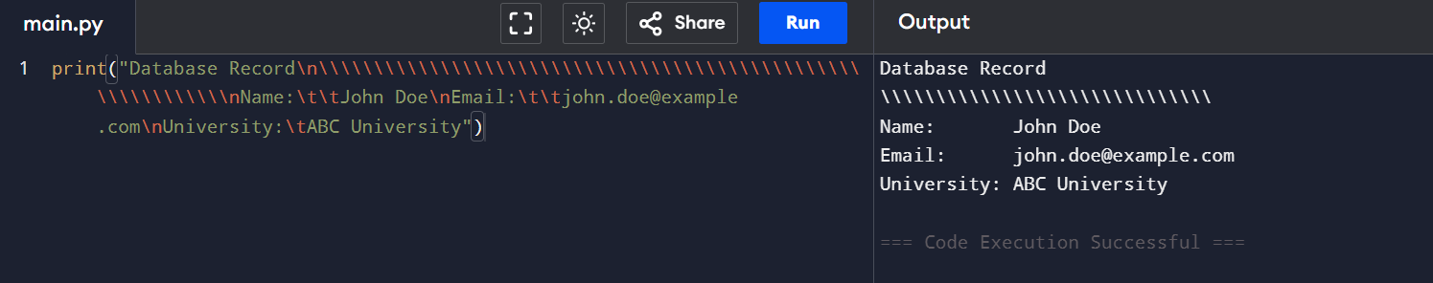

Problem 2. Using Placeholders for Email Details: Use appropriate type specifiers %s, %d, %f etc… for this task
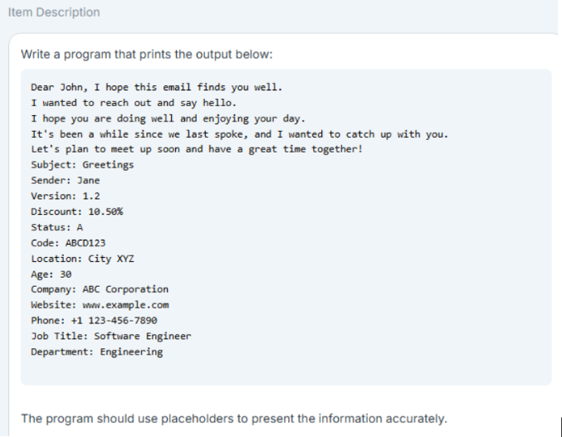
Code:
  - name = "John"
  - sender = "Jane"
  - version = 1.2
  - discount = 10.50
  - status = "A"
  - code = "ABCD123"
  - location = "City XYZ"
  - age = 30
  - company = "ABC Corporation"
  - website = "www.example.com"
  - phone = "+1 123-456-7890"
  - job_title = "Software Engineer"
  - department = "Engineering"

  - print("Dear %s, I hope this email finds you well." % name)
  - print("I wanted to reach out and say hello.")
  - print("I hope you are doing well and enjoying your day.")
  - print("It's been a while since we last spoke, and I wanted to catch up with you.")
  - print("Let's plan to meet up soon and have a great time together!\n")
  - print("Subject: Greetings")
  - print("Sender: %s" % sender)
  - print("Version: %.1f" % version)
  - print("Discount: %.2f%%" % discount)
  - print("Status: %s" % status)
  - print("Code: %s" % code)
  - print("Location: %s" % location)
  - print("Age: %d" % age)
  - print("Company: %s" % company)
  - print("Website: %s" % website)
  - print("Phone: %s" % phone)
  - print("Job Title: %s" % job_title)
  - print("Department: %s" % department)

Sample output:
Dear John, I hope this email finds you well.
I wanted to reach out and say hello.
I hope you are doing well and enjoying your day.
It's been a while since we last spoke, and I wanted to catch up with you.
Let's plan to meet up soon and have a great time together!

Subject: Greetings
Sender: Jane
Version: 1.2
Discount: 10.50%
Status: A
Code: ABCD123
Location: City XYZ
Age: 30
Company: ABC Corporation
Website: www.example.com
Phone: +1 123-456-7890
Job Title: Software Engineer
Department: Engineering
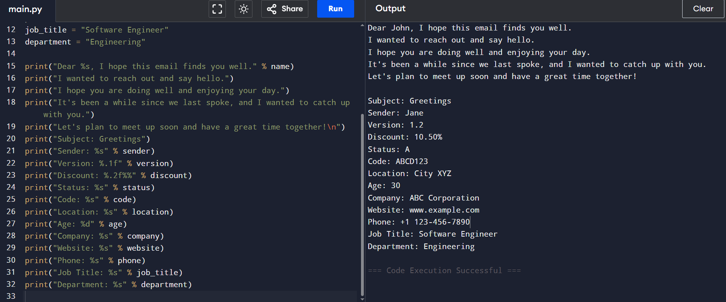
Problem 3. Book Reservation; Accept User Input
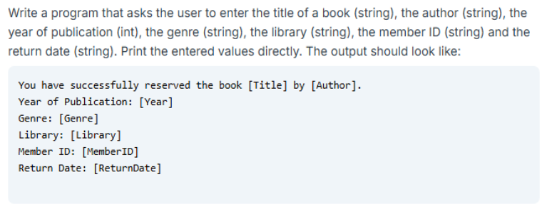
Code:
  - title = input("Enter the book title: ")
  - author = input("Enter the author: ")
  - year = int(input("Enter the year of publication: "))
  - genre = input("Enter the genre: ")
  - library = input("Enter the library: ")
  - member_id = input("Enter the member ID: ")
  - return_date = input("Enter the return date: ")

  - print("\nYou have successfully reserved the book '%s' by '%s'." % (title, author))
  - print("Year of Publication: %d" % year)
  - print("Genre: %s" % genre)
  - print("Library: %s" % library)
  - print("Member ID: %s" % member_id)
  - print("Return Date: %s" % return_date)

Sample output:
Enter the book title: 1984
Enter the author: Orwell
Enter the year of publication: 1949
Enter the genre: Dystopian
Enter the library: Central
Enter the member ID: 12345
Enter the return date: 2023-07-10

You have successfully reserved the book '1984' by 'Orwell'.
Year of Publication: 1949
Genre: Dystopian
Library: Central
Member ID: 12345
Return Date: 2023-07-10
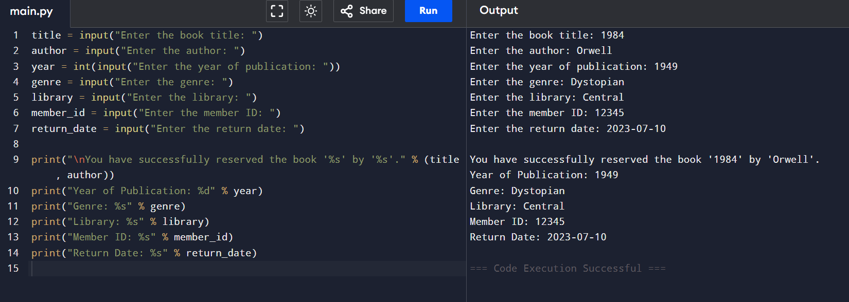

Problem 4. Day Identifier
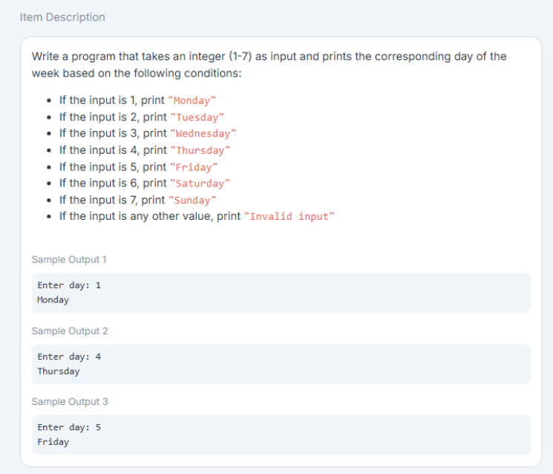
Code:

  - day = int(input("Enter day: "))

  - if day == 1:
  - print("Monday")
  - elif day == 2:
  - print("Tuesday")
  - elif day == 3:
  - print("Wednesday")
  - elif day == 4:
  - print("Thursday")
  - elif day == 5:
  - print("Friday")
  - elif day == 6:
  - print("Saturday")
  - elif day == 7:
  - print("Sunday")
  - else:
  - print("Invalid input")

Sample output:
Enter day: 1
Monday

Enter day: 4
Thursday

Enter day: 9
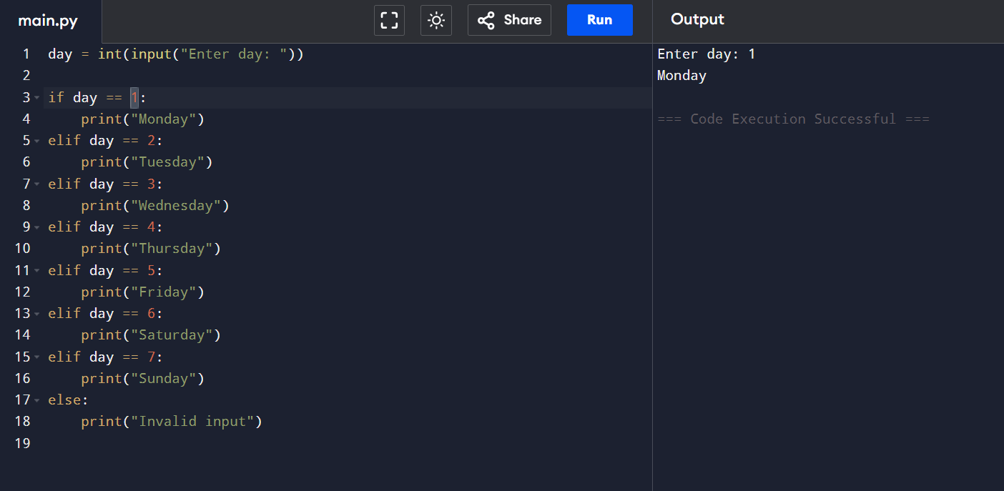
Invalid input

